Staff as reflective practitioners is the key to staff development.
Continual whole staff CPD is paramount to keeping teachers on point with changes in pedagogy and educational research. However, this on its own is not enough to develop teachers. The issue we found was that some staff are not necessarily aware of their own strengths or weaknesses or that they have time to reflect themselves or even on their own practice. Being a reflective practitioner is not just about fulling the teaching standards, but is central to improving teaching and learning within school. It enables staff to consider how students learn while looking at their own skills. They can then highlight for themselves barriers for learning so that staff can feel confident to enable them to address in their own lessons. This was part of the need to profile. The fact that some staff felt challenged by the thought of the ‘test’ should help to open their eyes about how pupils may feel during high stress environments in lesson and how this might affect outcomes, while others may have flourished, because of what they perceived be the completive nature of the task. Reflection as a tool for moving things forward has long since been a part of learning theory. Kolb (1984) developed a four stage model that he proposed as a continual cycle to move practice forward and aid development.

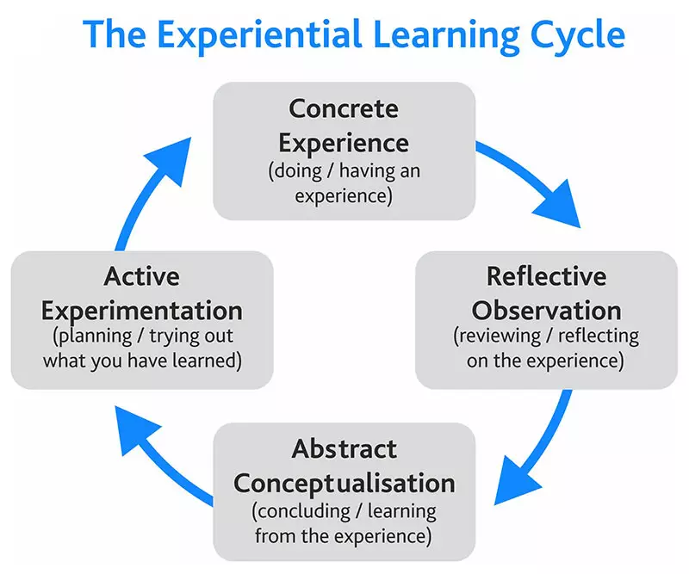
Source: https://www.skillshub.com/what-are-kolbs-learning-styles/
The whole process focusses on having the lived experience, reflecting on that and then reflecting further on how to move things forward. These ideas are then put into practice and the method continues again. This why the coaching sessions need to be at regular intervals to enable the process to have maximum impact.
Gibbs (1998) model, later added the importance of reflection on feelings as well as putting an action plan in place.
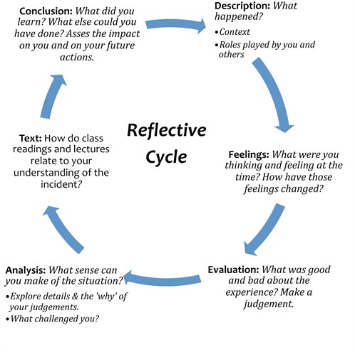
source:http://genuardis.net/reflective/reflective-cycle-gibbs.htm
This is why, as you will read later that matching the Coachee and Coach correctly is so important, as the two need to build a relationship in which they feel able to discuss these things, while providing a springboard for future goal setting. Gibb’s model fits beautifully with the educational coaching as it is centred around reflective questioning stage. It demonstrates clearly the importance of the Coach as the questioner and the listener while the Coachee reflects. Asking the deeper questions, makes the whole process more meaningful and more effective.

Reflection is a basic part of teaching and learning. It aims to make you more aware of your own professional knowledge and action by ‘challenging assumptions of everyday practice and critically evaluating practitioners’ own responses to practice situations’ (Finlay, 2008). The reflective process encourages you to work with others as you can share best practice and draw on others for support. Ultimately, reflection makes sure all students learn more effectively as learning can be tailored to them. (Cambridge Assessment, 2023).
Coaching not only gives staff that much needed time to talk through how things are going and take stock of the half term but can be used to guide individual staff members to review their own skill set and find new ways to contribute to the school.

