Term 2: I will…
The Guiding Star sets out the key aspects of the Trainees’s teaching life (related to the CID) that are crucial to wellbeing and job satisfaction. When life is going well, people can feel like a shining star, but if things begin to fall away and we feel challenged, sometimes the light begins to fade. Below are the six components on the Guiding Star. The idea is to have a go at scoring each aspect of your training so far, where the point of the Star represents 10 (the best it could possibly be) and the middle of the Star represents 1 (the worst it could possibly be). We will outline the sessions below.

The Guiding Star: I will…

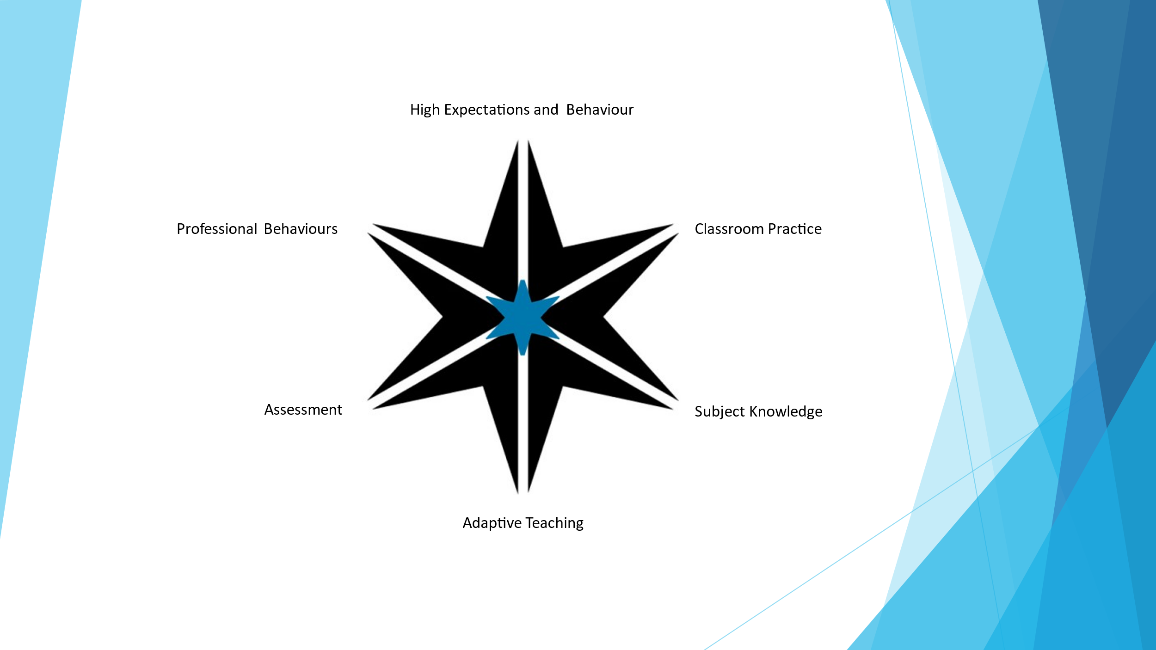

This will be an 8 week Phase, with a session every 2 weeks.

Phase 1 – Recap, review, Build relationship with new Mentor. The Allium Assay! Explain the coming term with the new Mentor, ask to score the Guiding Star before next session.

I

Phase 2. Reflect on Outcomes. Target Questions where needed, 2 Targets they feel need most attention.

II

Phase 3 – Review progress. Revisit the Guiding Star, choose 1 more area

III

Phase 4 – Redo the Guiding Star. Compare, is there a change? Discuss

IV

Phase 1:
Recap, Review, Build Relationship.
Remember from term 1…The key to effective Coaching is the relationship between Coach and Coachee. This must be built on a foundation of trust and understanding. This first session again looks to try and re-create that relationship. You can use The Allium Assay here as a nice ‘ice breaker’ to gauge where they are with their training at the moment. Ask them, ‘where do you sit on the tree at the moment and why? ’It is nice here to reflect on last term. This session will also look to explain the process of the Guiding Star for this term. We recommend an easy session, building the relationship. A brief overview at the end of the session to explain, Autumn Term…look at the Guiding Star and rate yourself from 1-10 on each area. Keep it brief and allow them to take away and do it in their own time. Explain that the next session will focus on the outcomes of the scoring.

Phase 2:
Reflect on outcomes.
It is a good idea here to look at the section on Goal Setting to remind oneself of why we set Goals.
Remember from term 1…To implement goals, one needs to have integrity and stick to the commitments. Successful implementation is all about a focus on behaviour – if one behaves in a way that is congruent with achieving goals, then, one is more likely to succeed. This session will be a review of the Star and how they scored themselves from 1-10 on each area. There will naturally be two areas that stand out from the rest and this is where we use our questioning techniques to explore their outcomes. Remember, one could ask for example:-
- How did you find the process? Why?
- What did you find that may have surprised you? How did that make you feel?
- Do you agree with the outcome? If yes/no then why?
We do not want to strangle the Coachee with too many questions, but rather get them used to the idea of opening up and being listened to. Remember, the ratio for talk should be 80%-20%. The Coach should not be telling their story or looking to offer judgement or reasons for answers, they are simply their to offer prompts for reflection and listen.
Once you have listened and been able to make the Coachee feel at ease with the process and they can see that it is focussed on them, end the session by explaining that next time you meet it will focus more on how they view themself and ask them to reflect on this before the session.

Phase 3:
Review Progress.
Always look to begin a session with questions to make them feel at ease and that you are there to listen to them and not judge or wax lyrical about yourself. We want to revisit the Teaching Star and look at the scoring again, but this time ask them to choose one more area that they may have felt could also be reviewed. It is all too easy to overlook areas when one is scoring alone without a Coach. This is where the Coach needs to probe a little deeper into the other areas and begin to link these to the Coachee’s Wellbeing. Remember, that this is an exercise in reflection and not prescriptive targets or blame culture as to why something may be less than expected. We want the Coachee here to feel supported and able to open up about an area that they feel may still need some exploration. This can form the end of the session, where one more goal is set to reflect on the final point of the Star.

Phase 4:
Redo the Guiding Star.
We are looking here at a complete circle of reflection on their progress to date and their achievements. A second look at the Guiding Star and quick scoring session will begin the dialogue about their journey so far. This is where the it comes together to really enable the Coachee to reflect on the year and process so far. Coaching is about balance. It focuses on removing obstacles and obstructions that people face in day to day life. It is about putting the onus on the individual to create a change process, where Coaching is there to help with this process and not just give the answers, but allow the individual to think through the processes at work. It is primarily about change, empowering the individual to begin a transformation in their life, evaluating their current situation and identify the process needed to undertake change. We want them to see that the Guiding Star has been a factor in this change process and how it can help them to become more self-reflective. The coaching side then helps to facilitate this, forming a bond with the individual and creating a reciprocal relationship of trust.. Sometimes though the Coach must be willing to prompt the individual if they are having difficulty, skilfully guide them on the right path. This guiding is where this session should lead the Coachee. They should be able at this point to talk openly about their goals, the journey and if they feel they have achieved or began to achieve what they initially set out to do. Remember, we are not there to judge, cross-examine or assess, we are there to listen and guide them onto the next step of their journey. The process and sessions to date should have helped to create the relationship of trust and exploration of Wellbeing. At this point, we want them to be able to leave the session with a sense that they have been listened to, can be open with someone and know that this will carry on.

Brief synopsis of point of the Guiding Star.
When reflecting on the eight points of the Star, one can consider this quick guide to some of the more salient points.

1, Professional Behaviours
- This can include sport clubs, extra-curricular activities, extra lessons with pupils, music and singing clubs, revision sessions, trips and visits, online tutorials, individual pupil mentoring and additional pastoral work. Also parents’ evenings. We found staff often overlook what they do and it is important to look at the different skills and talents that staff possess.

2, High Expectations and Behaviour
- This can include expectations of pupils and outcomes, as well as the expectations teachers put upon themselves. Is there an expectations that one should be in early and leave late, work every weekend and holiday. Should I volunteer for every school activity and trip. Naturally a key area for discussion and an area that is never mastered and always worked on. Try not to let the session become a forum for ‘complaints’ try to be proactive and positive. These are the questions we felt were raised, reflecting on the Wellbeing of Teachers.

3 Subject Knowledge
- Do I know enough? We found that this was an overwhelmingly positive area, teachers often feel confident with their own subject knowledge.

4, Resourcing
- How many hours should I spend planning? Must I create new resources for every topic? Do I plan daily, weekly, termly? Is it OK to share resources or should I just keep my own? This was an area that raised good questions for self-reflection and interestingly self-criticism.

5, Adaptive Teaching
- An area for teachers to look at if the lesson is planned to meet the needs of all pupils, not just differentiated worksheets, but a more holistic approach, where teachers can even adapt throughout the lesson. How do teachers deal with pupils, effective differentiated questioning, this was an area that offered a lot of discussion.

6, Assessment and progress
- This can be looked at through class tests, homework, end of unit assessments or prep exams. Pupil progress is the key to what all teachers are looking to achieve, so should be at the forefront. We found many teachers naturally were concerned about progress, so is a key area to discuss.

Conclusion
Now look back at your Guiding star – which spokes need some urgent attention and what are you going to do about them?

