Term 3: I can…
Future proofing the teacher and reflection on process.
The coaching process now moves to an ‘I can…’. The thought behind this is that it moves to looking forward, perhaps to ECT year 1, but thinking about their role, now that they are more reflective and more aware of their own strengths, within the educational setting. It helps to avoid solo mentality and will hopefully enable a more strategic approach within departments and therefore the whole school.
This method will help to foster a coaching culture, encourage continual professional growth and also encourages peer collaboration and consultation and they move into their ECT year. It is imperative to the success of this part of the model that the sessions do not turn into purely Goal Setting. It is easy, due to the busyness and pressure of the teaching profession for these sessions to digress into talking about the Goals set through the SCITT programme. Rather it should be a forward thinking set of sessions, to help prepare for the ECT year.

Fly Forward: I can…

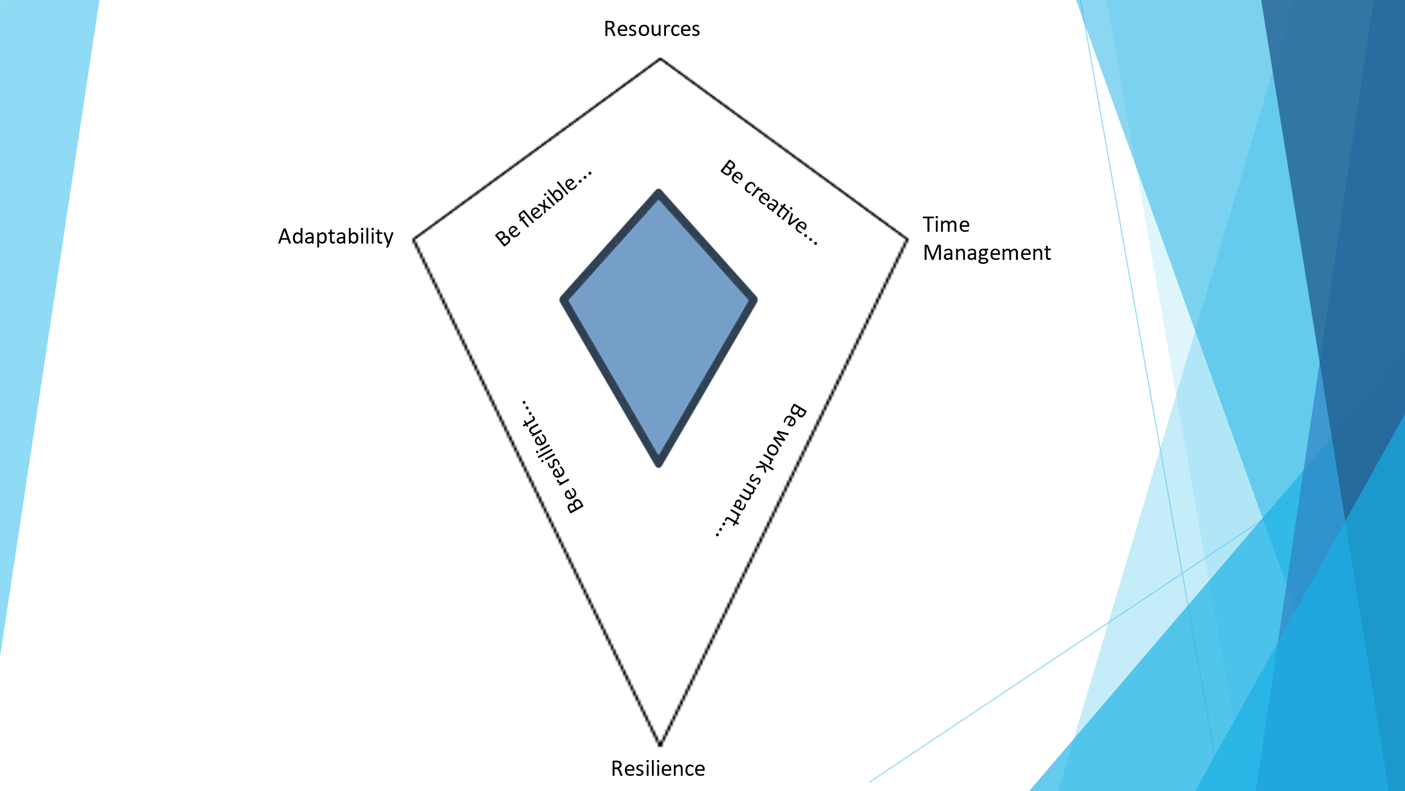

This will be an 8 week Phase, with a session every 2 weeks.

Phase 1 – Resilience. How have I coped this year so far and what strategies will I employ going forward? Re-build the relationship from Term 1.

I

Phase 2 - Adaptability. What does this mean for me?
II

Phase 3 – Resource. A chance to reflect on resourcing so far and what will I need for the future?
III

Phase 4 – Time Management. How do I work smart?

IV

Phase 1:
Resilience.
The key to the success of any Trainee or teacher is that people can work well with each other, trust each other and can depend on one another and be resilient. This session will look to explore and build on the strengths that already exist. Positivity, praise and passion need to flow through this session, looking to value the Trainee and their input. It may be necessary to ask some leading questions here, to help them to begin reflecting on how collaboratively they work. One could begin by asking, ‘do you enjoy team activities or do you prefer working individually?’, ‘what is your preferred working style?’, ‘how do you feel about deadlines?’, ‘do you feel valued when you have achieved something?’, ‘how do you resolve disagreements?’ ‘How else could this be approached…?’, ‘How do you plan to deal with…?’, ‘How are you willing to change if…?. Remember the Coach is a facilitator here, it is not their role to lead, rather to mediate and steer the discussions (as well as take part, leading from the front), so that the Trainee has a voice and can be heard. This is the first session for the term and will set the tone for the forthcoming sessions, it is vital that it is led with positivity and then the Trainee gets the opportunity to be heard in a safe and non-judgemental environment.

Phase 2:
Adaptability.
Successful Wellbeing will be values-driven, people-focused, and willing to challenge the ethos to empower a wellbeing culture within the Trainee. Sometimes this can involve asking difficult questions when discussing wellbeing and asking Trainees to ‘come out of their comfort zone.’ This session will inevitably be an organic process, where one cannot predict the theme, feeling or outcome. However, one could lead the session with some sample questions, like ‘Do you enjoy working in the classroom?’, ‘What do you do to address the needs of pupils?’, ‘How do you react to an unplanned occurrence in the classroom?’, ‘Is there a supportive culture within the Department?’, ‘Do you always stick rigidly to your lesson plans…why’, ‘Are you happy with your work/life balance?’, ‘Do you believe you have all the tools to do your job effectively?’. Again, try to steer the discussion away from complaining about behaviour or ineffective IT and try to focus on positive pro-active outcomes rather than a moaning culture. Look for solutions, not problems.
Wellbeing needs to:
- Challenge the Trainee to include teacher Wellbeing in everything they do and actively create a ‘culture of Wellbeing’, to care for people who care for others.
- Members within the Department can act as a ‘critical friend’ to question the impact of decisions on teacher Wellbeing – just as important as Quality Assurance or Performance Management, wellbeing needs to flow through all that we do and focus on.
- Ensure that the Head of Department or Lead is supportive with their Wellbeing of the Trainee.
- Focus on equality, diversity and inclusion, ensuring that the Department considers the needs of the diverse groups within it and adapts holistic approaches to Wellbeing, appreciating peoples changing needs over time.
- Continually and strategically ‘sense-check’ the wellbeing agenda of the Trainee and prompt improvement / developmental action if needed. Remember, this is a really stressful term for them, with final assessment pending.
- Demonstrate that the Mentor takes personal Wellbeing responsibilities seriously. This is where listening again becomes key, Trainees need to be heard and listened to, not just told how to respond.
From a personal perspective, the Wellbeing session needs to:
- Strategically influence and shape the wellbeing agenda, ensuring that the Trainee feels heard and listened to.
- Hold the values reflected in the role description, role modelling the values of fairness, compassion and inclusivity.
With this in mind, the Coach does not need to be a Wellbeing expert, take on executive/management responsibilities for ensuring Wellbeing policies are operationally actioned and delivered, get involved in ‘the doing’, operational management, or individual cases or personally collect, analyse or present data on Wellbeing. Rather they should be able to open up themselves and lead from the front, be able to actively listen and allow the Trainee to speak in a forum of open and non-judgemental discussions.

Phase 3:
Resource.
Learning can happen in a myriad of different places, activities, methods, ways and time frames. This can vary from the lecture hall, to listening to an instructor to a one-on-one mentorship program, from interactive online platforms, to complex textbooks, there are so many formats that learning can take. There are many different learning techniques, as well as many styles of teaching and learning, all of which combine to make every learning experience different. Within teaching, this can also vary greatly, from online courses, face to face, group or individual CPD and even higher-level learning such as MAs or PHDs. The key question is ‘are Trainees using resources to instructionally or are risks also being taken?’. The Mentor and even the whole team needs to be open here to new ideas and must also try to be able to guide the individual in a way that is realistic and positive to both parties. After the discussion, it may be necessary to then have a meeting with the Teaching and Learning Lead to obtain advice as to how and where this personal growth can be achieved, if resourcing is an issue. The first port of call must always be to look at expertise in-house and then look further afield to try and accommodate the needs of the individual. Remember, we are looking to create an open and honest discussion here where personal learning can be approached and evaluated. Be open, positive and honest in your approach, for this will wield the best results.

Phase 4:
Time Management.
It is very natural for teachers to spend time thinking about what they did in the classroom, why they do certain things and if it is working. Reflective practice is purposeful reflection at the heart of a structured cycle of self-observation and self-evaluation for continuous learning. When a teacher is self-reflective, it helps them move from just experiencing a lesson, to understanding what happened and why. Taking the time to reflect on and analyse teaching practice helps to identify more than just what worked and what did not. This level of self-awareness is a powerful tool, as teaching is an ever changing culture, even within a single lesson, one may change a focus, resource or even an outcome. A culture of reflective practice creates a strong foundation for continuously improving teaching and learning, which is the ultimate goal of every teacher. In an environment where teachers collectively question and adapt, draw on expertise and support one another - pupil learning benefits. This again is the powerful tool of collaborative working. It sends the message that learning is important for both pupils and teachers. It also creates an environment of collaboration, as teachers question and adapt both their own practice and that of their colleagues. The Trainee needs to be guided here on real applicable ways of the ‘Work Smart’ ethos. These could include, monotasking, go back to pen and paper, create an organised workspace, prioritise tasks, allocate time to tasks, use the ‘Pomodoro technique’ and probably most importantly…ask questions. The self-reflection should and must not necessarily just focus on what happens in the classroom, but must also focus on the individual and their Well-being. It should again be a safe place to explore personal issues or concerns, if they feel comfortable approaching it. It may not be easy discussing personal issues, but this is where we can return to the ideas and ethos of terms 1 and 2, where the focus on personal Wellbeing is key. The discussions could look like this…
- Monotasking: ‘What specifically am I trying to accomplish right now?’, ‘Why is it important?’, ‘What obstacles might I face?’, ‘ How might I address them so that I can still make progress on my goal?’. The discussion can focus on these key areas, when people are encouraged to focus on one task at a time, eliminating distractions, productivity increases while burnout and turnover decreases. The American Psychological Association found that doing more than one task at a time, or switching between tasks, reduces productivity by 40%.
- Go back to pen and paper. This may sound like a step backward, but creating a physical list, that can be seen and then crossed out can be a powerful psychological tool.

- Create and organised work space. Having a tidy area where things can be found and organised quickly, will help keep Trainees on track.

- Prioritise tasks. This will help reduce stress and increase productivity, create room to check errors, give you more time to relax, help avoid procrastination and will keep Trainees motivated. The spinning of plates is a real skill, guiding them to learn which ones to spin and when, will undoubtedly lead to better Wellbeing.

- Pomodoro technique. The secret to effective time management is...thinking in tomatoes rather than hours. It may seem silly initially, but it is a proven technique created by Francesco Cirillo. (Pomodoro is Italian for tomato. 🍅)
This popular time management method asks you to alternate Pomodoros — focused work sessions — with frequent short breaks to promote sustained concentration and stave off mental fatigue. It could be discussed as such..

- Get a to-do list and a timer.
- Set your timer for 25 minutes, and focus on a single task until the timer rings.
- When your session ends, mark off one pomodoro and record what you completed.
- Then enjoy a five-minute break.
- After four Pomodoros, take a longer, more restorative 15-30 minute break.

- This is a good technique to try if, you find little distractions often derail the whole workday, consistently work past the point of optimal productivity, have lots of open-ended work that could take unlimited amounts of time, are overly optimistic when it comes to how much you can get done in a day, enjoy goal-setting, which is a key element of Term 1 and the I am Phase.

- Ask questions. This will be 100% key to a successful work smart ethos. Trainees can be too shy, nervous or insecure to ask questions. This is why we should try and foster an atmosphere, where it is OK to ask for help, guidance and support. We all had to start somewhere!

